10. Create a Cloning of a VM and Test it by loading the Previous Version/Cloned VM using virtual box.
Aim: To clone a Virtual Machine in VirtualBox and verify the cloned VM by running it and comparing it with the original VM configuration.
Procedure:
- Open Oracle VM VirtualBox on your system.
- Select the Virtual Machine you want to clone (ensure it is powered off).
- Right-click on the VM and select Clone… from the context menu.
- The Clone Virtual Machine Wizard will open — click Next.
- Enter a name for the cloned VM and select a location to save it.
- Choose Full Clone (independent copy) or Linked Clone (shares disks with original) ➜ Click Next.
- Optionally, choose to reinitialize the MAC address for the cloned VM.
- Click Finish to start the cloning process.
- After cloning, start the cloned VM to verify its functionality.
- Compare the cloned VM with the original VM to ensure the configuration, OS, and installed software match, confirming successful cloning.
Output:
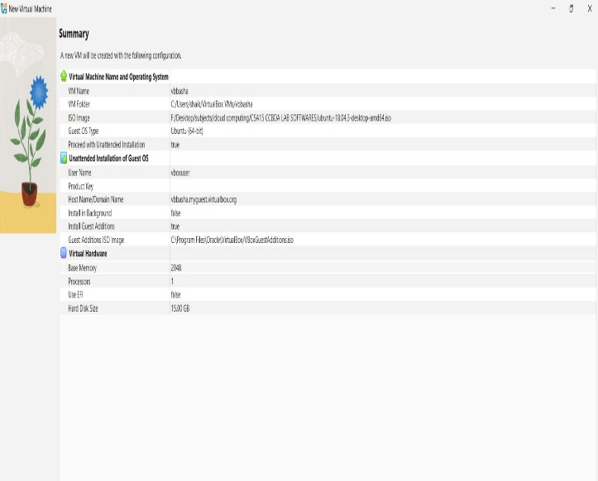
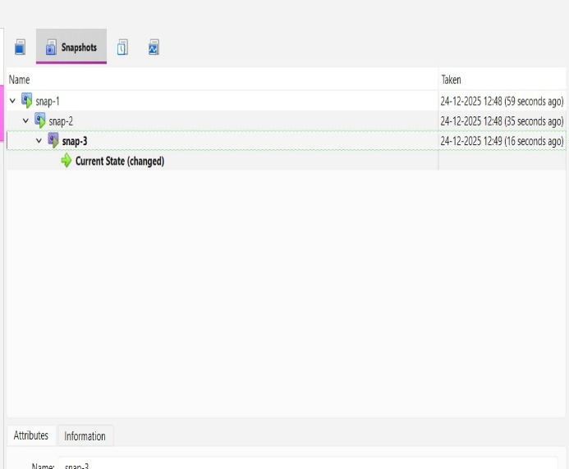
Result:
The Virtual Machine was successfully cloned using VirtualBox.
The cloned VM operated independently and maintained the same configuration as the original, verifying the cloning process works correctly for testing or backup purposes.

